ID : 171-15-8596

Part - A

SQL> Create table Orders(

2 OrderID int not null primary key,

3 OrderDate date,

4 CustomerID int

5 );

Table created.

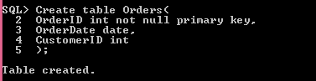

SQL> Create table Product(

2 Product varchar(20) not null primary key,

3 UnitPrice Number(5,2)

4 );

Table created.

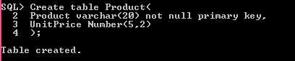

SQL> Create Table OrderDetails(

2 OrderID int not null,

3 Product varchar(20) not null,

4 Quantity int,

5 Foreign Key (OrderID) references Orders(OrderID),

6 Foreign Key (Product) references Product (Product)

7 );

Table created.

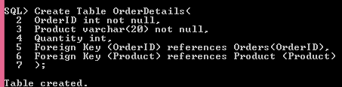

SQL> Create Table Customers(

2 CustomerID int not null primary key,

3 Customer varchar(50),

4 Address varchar(50),

5 DateofBirth date

6 );

Table created.

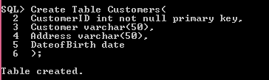

SQL> Create Table Phone(

2 Customer int not null,

3 PhoneNumber varchar(30),

4 Foreign Key (Customer) References Customers (CustomerID)

5 );

Table created.

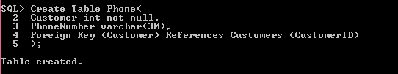

SQL> Insert all

2 Into Orders (OrderID, OrderDate, CustomerID) values (1, TO_DATE('02-Jan-16

, 'DD-MON-YY'), 101)

3 Into Orders (OrderID, OrderDate, CustomerID) values (2, TO_DATE('02-Jan-16

, 'DD-MON-YY'), 163)

4 Into Orders (OrderID, OrderDate, CustomerID) values (3, TO_DATE('03-Jan-16

, 'DD-MON-YY'), 302)

5 Into Orders (OrderID, OrderDate, CustomerID) values (4, TO_DATE('03-Jan-17

, 'DD-MON-YY'), 302)

6 Select * from dual;

4 rows created.

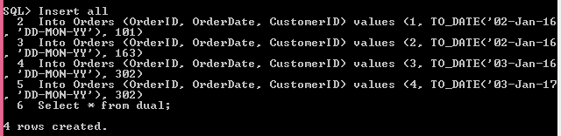

SQL> Insert all

2 Into Product(Product, UnitPrice) values ('CD-2903', 12.99)

3 Into Product(Product, UnitPrice) values ('BA-8327', 1.5)

4 Into Product(Product, UnitPrice) values ('BA-2349', 5.99)

5 Into Product(Product, UnitPrice) values ('BE-2908', 10)

6 SElect * from dual;

4 rows created.

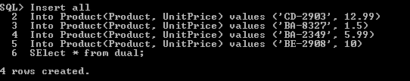

SQL> Insert all

2 Into Customers (CustomerID, Customer, Address, DateofBirth)

3 values(101, 'Wendy Khan', '1399 Firestone Drive', TO_DATE('23-Nov-70', 'D

-MON-YY'))

4 Into Customers (CustomerID, Customer, Address, DateofBirth)

5 values(163, 'Linda Leiser', '1318 Lasalle Street', TO_DATE('16-Jul-82', 'D

-MON-YY'))

6 Into Customers (CustomerID, Customer, Address, DateofBirth)

7 values(302, 'Mike Seaman', '9539 Glenside Drive', TO_DATE('30-Mar-16', 'D

-MON-YY'))

8 Into Customers (CustomerID, Customer, Address, DateofBirth)

9 values(401, 'Abdul Kalam', '1212 Dhaka', TO_DATE('01-Jan-93', 'DD-MON-YY')

10 select * from dual;

4 rows created.

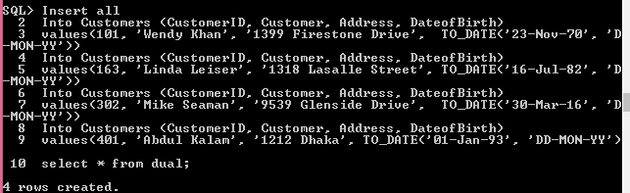

SQL> Insert all

2 Into Phone(Customer, PhoneNumber) values(101, '3545435413')

3 Into Phone(Customer, PhoneNumber) values(101, '36465465436')

4 Into Phone(Customer, PhoneNumber) values(163, '34643434')

5 Into Phone(Customer, PhoneNumber) values(163, '34134213242')

6 Into Phone(Customer, PhoneNumber) values(302, '35432434')

7 select * from dual;

5 rows created.

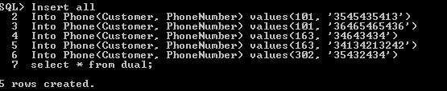

Part – B

SQL> SElect Customer

2 From Customers

3 Where trunc((sysdate - TO_DATE('18-Mar-19', 'DD-MON-YY')) / 365.24) < 15;

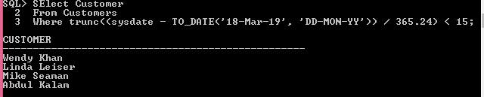

2.

SQL> SElect Customer

2 From Customers

3 Where Customer Like '%s%';

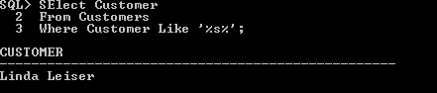

3.

SQL> Select count(OrderID)

2 From Orders

3 Where OrderDate between

4 TO_DATE('01-Jan-18', 'DD-MON-YY')

5 and

6 TO_DATE('31-Dec-18', 'DD-MON-YY')

7 ;

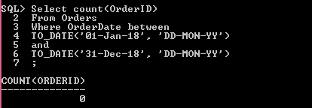

4.

SQL> Select Product

2 From Product

3 Where UnitPrice =

4 (Select max(UnitPrice) From Product);

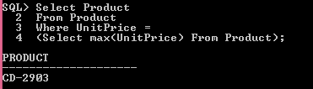

5.

SQL> Select Customers.Customer

2 From Customers INNER JOIN Phone ON

3 Customers.CustomerID = Phone.Customer

4 where Phone.PhoneNumber like '%1%';

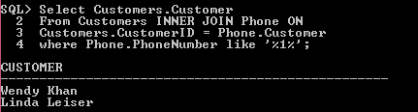

6.

SQL> Select sum(OrderDetails.Quantity * Product.UnitPrice)

2 From ((OrderDetails

3 INNER JOIN Product ON

4 OrderDetails.Product = Product.Product)

5 INNER JOIN Orders ON

6 OrderDetails.OrderID = Orders.OrderID

7 and Orders.OrderDate between

8 TO_DATE('01-Jan-18', 'DD-MON-YY')

9 and

10 TO_DATE('31-Dec-18', 'DD-MON-YY')

11 );

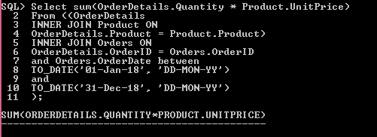

Part-C

SQL> Create Table Customer2(

2 Id int not null Primary key,

3 FirstName varchar(50),

4 LastName varchar(50),

5 City varchar(50),

6 Country varchar(20),

7 Phone varchar(20)

8 );

Table created.

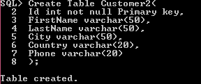

SQL> Create table Orders2(

2 Id int,

3 OrderDate date,

4 OrderNumber int,

5 CustomerId int not null,

6 TotalAmount number(10,2),

7 Foreign Key (CustomerID) references Customer2 (Id)

8 );

Table created.

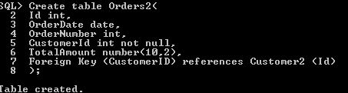

SQL> Insert all

2 into Customer2(Id, FirstName, LastName, City, Country, Phone)

3 values(1, 'A', 'B', 'Dhaka', 'BD', '12345')

4 into Customer2(Id, FirstName, LastName, City, Country, Phone)

5 values(2, 'A', 'B', 'Dhaka', 'BD', '12345')

6 into Customer2(Id, FirstName, LastName, City, Country, Phone)

7 values(3, 'A', 'B', 'Dhaka', 'BD', '12345')

8 into Customer2(Id, FirstName, LastName, City, Country, Phone)

9 values(4, 'A', 'B', 'Dhaka', 'BD', '12345')

10 into Customer2(Id, FirstName, LastName, City, Country, Phone)

11 values(5, 'A', 'B', 'Dhaka', 'BD', '12345')

12 into Customer2(Id, FirstName, LastName, City, Country, Phone)

13 values(6, 'A', 'B', 'Dhaka', 'BD', '12345')

14 into Customer2(Id, FirstName, LastName, City, Country, Phone)

15 values(7, 'A', 'B', 'Dhaka', 'BD', '12345')

16 into Customer2(Id, FirstName, LastName, City, Country, Phone)

17 values(8, 'A', 'B', 'Dhaka', 'BD', '12345')

18 into Customer2(Id, FirstName, LastName, City, Country, Phone)

19 values(9, 'A', 'B', 'Dhaka', 'BD', '12345')

20 into Customer2(Id, FirstName, LastName, City, Country, Phone)

21 values(10, 'A', 'B', 'Dhaka', 'USA', '12345')

22 select * from dual;

SQL> Insert all

2 Into Orders2(Id, OrderDate, OrderNumber, CustomerId, TotalAmount)

3 values(1, TO_DATE('31-Dec-18', 'DD-MON-YY'), 1, 1, 1000.56)

4 Into Orders2(Id, OrderDate, OrderNumber, CustomerId, TotalAmount)

5 values(2, TO_DATE('30-Dec-18', 'DD-MON-YY'), 2, 2, 1000.56)

6 select * from dual;

2 rows created.

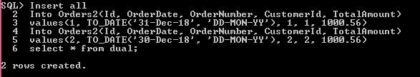

1.

SQL> Select count(Id), country

2 From Customer2

3 Group by Country

4 Having count(Id) >= 9

5 and Country not in ('USA')

6 Order by count(Country) Desc;

COUNT(ID) COUNTRY

---------- --------------------

9 BD

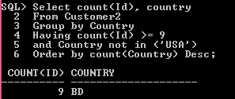

2.

SQL> Select FirstName

2 From Customer2

3 Where ID IN

4 (Select CustomerId

5 From Orders2

6 Group by CustomerId

7 Having avg(TotalAmount) between 1000 and 1200);

FIRSTNAME

--------------------------------------------------

A

A

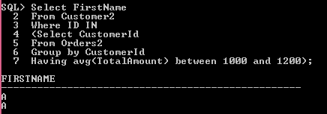

3.

SQL> Select count(Id), country

2 From Customer2

3 Group by Country

4 Having count(Id) > 10;

no rows selected

